24-08-2026

EXPERIMENT 23 – BIRD CAN FLY OR NOT

AIM
To write a Prolog program to determine whether a particular bird can fly or not.

ALGORITHM
- Start the program.
- Define facts for different birds.
- Define birds that can fly.
- Define birds that cannot fly.
- Query the bird and display the result.

PROGRAM
bird(eagle).
bird(parrot).
bird(pigeon).
bird(ostrich).
bird(penguin).

can_fly(eagle).
can_fly(parrot).
can_fly(pigeon).

cannot_fly(ostrich).
cannot_fly(penguin).

flies(Bird) :-
bird(Bird),
can_fly(Bird).

OUTPUT

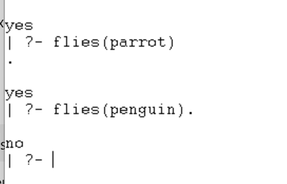

RESULT
Thus, the Prolog program was successfully executed to determine whether a bird can fly.

